Oyster Task Force Meeting
Tuesday, January 24, 2023, 1:00pm
New Orleans Lakefront Airport
6001 Stars and Stripes Blvd.
Mitch Jurisich, Chairman

Meeting began at 1:07pm
I. Pledge of Allegiance
II. Roll call and introduction of guests

Voting Members Present:
Dan Coulon
Jakov Jurisic
Mitch Jurisich
Brad Robin
Brandt Lafrance
Matthew Slavich
Sam Slavich
Willie Daisy
Steve Pollock

Voting Members Absent:
Shane Bagala
Tracy Collins
Ryan Mallory
Al Sunseri
Peter Vujnovich

Non-Voting Members Present:
Carolina Bourque
Jennifer Moon in for Justin Gremillion
Edward Skena
Sarah Roy
Harry Vorhoff

Non-Voting Members Absent:
Brian Lezina

III. Jakov Jurisic motioned to approve the December 13, 2022 meeting minutes, 2nd by Willie Daisy. Motion carries.

Brad Robin motioned to add an item under New Business, ‘A.1 To Discuss the Mid-Barataria Sediment Diversion and LDWF’s Plans Moving Forward, 2nd by Steve Pollock. Motion carries.

Brad Robin motioned to add and agenda item under New Business, E. To Consider Funding for Oyster Task Force Marketing, 2nd by Brandt Lafrance. Motion carries.

Brad Robin motioned to approve the agenda as amended, 2nd by Jakov Jurisic. Motion carries.
IV. Treasury Report
Remaining Fund Balance- $568,752
Remaining Budget Balance- $27,744
December oyster tag sales- 118,800 tags sold

Brad Robin motioned to approve the treasury report as presented, 2nd by Steve Pollock. Motion carries.

V. Committee Reports

- Public-Private Oyster Seed Grounds Committee Report- the committee met this morning and discussed the 15% allowance of dead shells and oysters under the size
Mitch Jurisich led discussion stating that there was some discussion about the possibility of letting harvesters go through their oysters, discard the undersized ones, and keep the market size instead of losing the whole load. There is a lot that needs to be looked into to make this change and the task force will continue discussions in the future; also discussed the 2023 Interstate Shellfish Sanitation Conference meetings that are coming up the week of March 18-23rd.
- Enforcement Report
December 1st – January 4th
Region 4 (Iberia)
None

Region 5 (Calcasieu and Cameron)
Cameron
None

Region 6: (Terrebonne, Lafourche, Grand Isle)
Lafourche
None

Region 8: (Jefferson, Plaquemines, St. Bernard, Orleans)
St. Bernard
1- Violate sanitation code-refrigeration
1- Violate sanitation code-waste bucket
2-Fail to tag oysters from seed ground-Nothing seized, allowed to tag, and sell.
26 Mini Sacks and 1 full sack seized
- Legislative Committee- no report
- Legal Committee- no report
- Research Committee- no report- Brian Callam has taken another position so Dr. Robertson is now the new director of the hatchery
- Coastal Restoration Committee- no report
- Marketing Committee- Marketing Committee met this morning and discussed the 2023 marketing objectives and plan. Anna Koehl stated that part of the plan is to build up social media and overall media awareness. Also to increase traffic to the website and the possibility of creating some marketing pieces for the upcoming 2023 LFF Summit. Also discussed digital strategies and search engine optimization.
- Health Committee- Jennifer Moon provided the report stating that there has been one new case of vibrio that is being investigated. Positive but the stereotype if unknown and is currently listed as a probable case. Baton Rouge case.
- Aquaculture Committee- no report
- Joint Task Force Working Group Committee- no report
VI. New Business
- The board discussed the Mid-Barataria Sediment Diversion on LDWF’s plans moving forward
Mitch Jurisich led discussion- the permit for the projected has been permitted. The task force sent letters to the Corp requesting a meeting with General Holland before the permit was granted and the request was denied. LDWF is supposed to represent the industry, feel as though through this whole process the industry has not been fairly represented. Have asked for help, not sure of the statute but thought that the purpose was to protect, promote and enhance the wildlife and fisheries of the great state of Louisiana. Feel like the industry has been abandoned in this process.
Jakov Jurisic stated that the oyster industry has gone to Washington, D.C. for years, spoke to all of the LA representatives, and stressed concerns regarding this project. After all of this time nothing has been done even after all of the industry’s efforts
Brad Robin stated why are spending all of this money for these biologists to go to school when there will not be a seafood industry anymore, no culture. There is 100s of years’ worth of anglers sitting at this table, millions of dollars invested and all of this will be gone in a few years due to this project
Sam Slavich stated that you could trace his business back for hundred years, the industry used to be encouraged to do what they do and they were respected, over the last 20-25 years the industry is no longer encouraged and no longer respected. LDWF has turned their back on the industry and has given their authority to other agencies who do not have the industry’s best interests in mind
Willie Daisy stated that the public needs to be notified of what is going on and how this will affect the oyster industry
A.1. the board discussed the Strike Force license fee
Mitch Jurisich led discussion stating that the Oyster Strike Force has been extinguished 7-8 months ago but the fee is still a part of the oyster harvester’s license. Would like to know what fund this money is going into and if it is staying within an oyster fund? Would like to add this item to next meeting agenda for further discussion and feedback.
Sam Slavich stated that there is a delay in issuing the licenses when renewed online, Edward Skena stated that there was an IT issue on the front end and back end, the issues were resolved and now they are catching up- enforcement is aware of this
- Travis Dardar provided a presentation on the Cameron Parish LNG Project

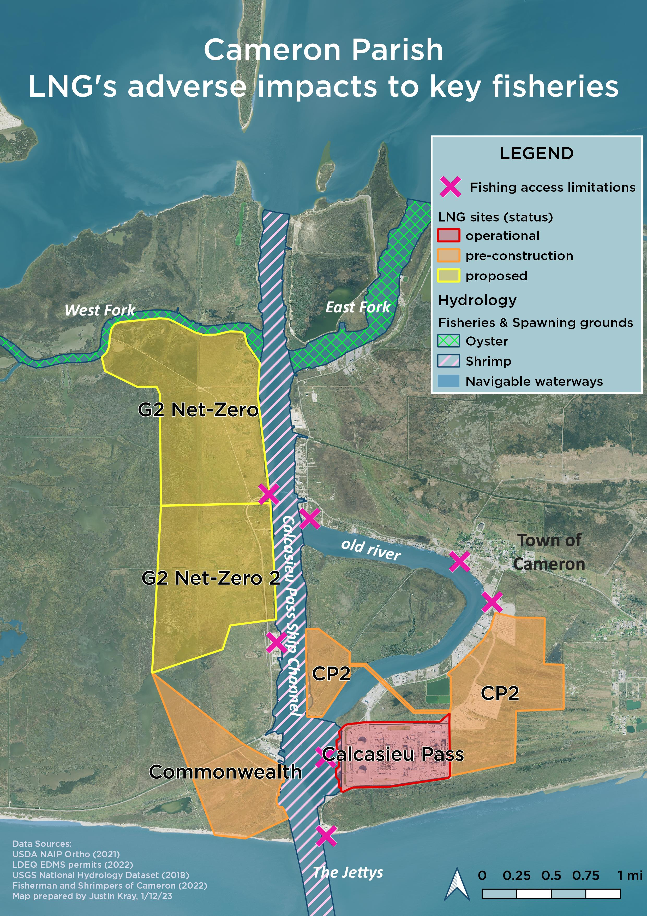
Travis Dardar expressed concern with how close the project is to his property and the impacts it will have on the local fisheries; issues with the buildout being located on the fishing grounds, loss of access to boat launches, etc.
Carolina Bourque stated that back in 2018 LDWF submitted a letter through the permit to re-route a pipeline and were successful in doing so. Now in this case, the permit is still open for public comment so any letters and comments all have to be submitted now, do not believe LDWF has submitted a comment on this permit for this project as of yet. LDWF has requested more information about the pipeline but has not received feedback yet.
Brad Robin stated that next OTF meeting have OTF representative from the area come to the meeting and provide some feedback on this.
Steve Pollock motioned to consider supporting a letter of opposition to the Cameron Parish LNG project, 2nd by Jakov Jurisic. Motion withdrawn.
Matthew Slavich motioned to defer the item until the Oyster Task Force has an opportunity to read proposed letter regarding the Cameron Parish LNG project before taking a vote on approving it, 2nd by Sam Slavich. Motion carries.
- Earl Melancon led discussion on industry interest in participating in a panel session at the State of the Coast 2023 Conference on the “State of the Private Oyster Industry in Louisiana’

The state is hosting a conference called the State of the Coast at the Convention Center in New Orleans from May 31st- June 2nd, this year Sea Grant is interested in hosting a 90 minute session dealing with the state of the private oyster industry and look into the history of the industry over the course of the last 20 years and how it has moved from the public-private to 99%, last year, private sector. Would like to indicate what the private sector is doing post Katrina and how the industry has changed investments and discuss challenges moving forward. Will probably begin with a 20-25 minute intro in bringing the audience up to date with the state of the industry today and then move into an hour discussion of 5 individuals representing the industry. Would like the task force’s feedback on their interest in participating in the session?

Darrah Bach with the Coalition to Restore Coastal Louisiana stated that the conference is being put on by the Coalition but is collaborating with others like CPRA, the Water Institute and Sea Grant. This is a bi-annual conference with people from all over the State/ and all throughout the country talking about the state of the coast of Louisiana, the environment, the economy and everything in between. Looking for participation from folks on the ground like the task force, fishing industry folks, and anyone with interest in coastal issues, coastal restoration and protection.

Brad Robin stated that he would be interested in speaking on the panel

Brad Robin motioned to support the session and discussion and the industry would like to participate, 2nd by Willie Daisy. Motion carries.

- The board discussed opening Sister Lake February 1, 2023 through February 28, 2023

Willie Daisy suggested opening the season with 20-25 sack/ day limit

Carolina Bourque provided a presentation:
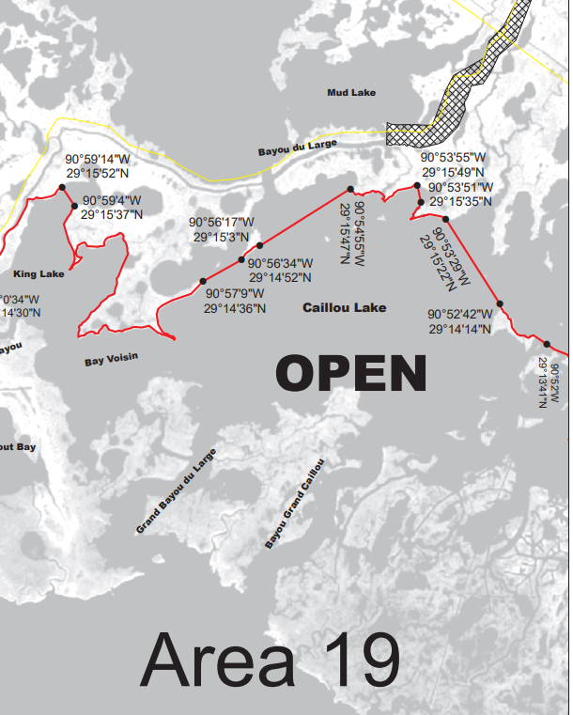
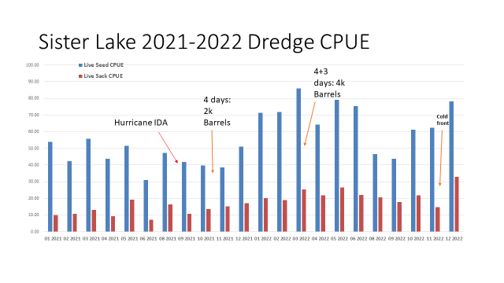
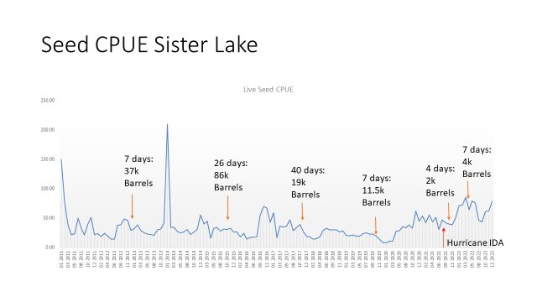
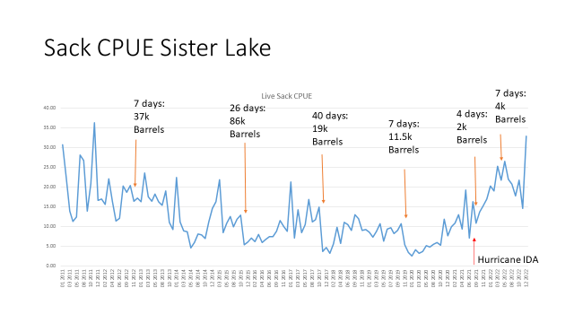
Carolina Bourque stated that LDWF has authority to open/ close this season with 72 hours’ notice, will need to look at the data and will have to present internally and see if chain of command and secretary approves of opening and see how long of season and how many sacks a day the lake can handle; stated that if there are poacher issues this needs to be reported to enforcement

Jakov Jurisic motioned to request that LDWF look into opening Sister Lake, 2nd by Brad Robin. Motion carries.

- The task force discussed funding for OTF marketing activities and the possibility of sponsoring a breakout room at the 2023 ISSC Conference

Brad Robin motioned to fund sponsoring a breakout meeting room, drinks, and pastries for the 2023 Interstate Shellfish Sanitation Conference, 2nd by Jakov Jurisic. Motion carries.

Jakov Jurisic motioned to approve funding $500 towards the printing of marketing materials for the 2023 LA Fisheries Forward Summit, 2nd by

- The board held officer elections

Jakov Jurisic motioned to nominate Mitch Jurisich as the chair and Peter Vujnovich as the vice chair, 2nd by Brad Robin. Motion carries.

Jakov Jurisic motioned to close the elections, 2nd by Brad Robin. Motion carries.

Jakov Jurisic motioned to amend the agenda, adding an item under new business, G. To Approve Changes to the Oyster Tag, 2nd by Brad Robin. Motion passes unanimously.

- Brad Robin motioned to approve the changes to the oyster tags as presented, 2nd by Willie Daisy. Motion withdrawn.

Steve Pollock suggested providing a little more space to write in the count

Brad Robin motioned to approve the changes to the oyster tags with 1 suggestion to allow for more space to write in the count, 2nd by Willie Daisy. Motion carries.

VII. Public Comment

Mike stated that he would suggest the option for fishermen to provide an in person or over the phone comment on the LNG project- a lot of these guys do not have access or do not know how to use the computer

Dr. John Zach Lea stated that he suggests that OTF encourage Sea Grant and LDWF that when a lease is subleased to an AOC farmer that the farmer is responsible for the lease, the equipment on the lease, etc.

VIII. Next meeting set for Tuesday, February 14, 2023 for 10am at the East Bank Regional Library.

IX. Brad Robin motioned to adjourn, 2nd by Jakov Jurisic. Motion carries.

